Essay Writing Tips
- Write about your personal experiences.
- Don’t try and include everything.
- Tell them something about you that they won’t get to see anywhere else in the application.
- Pull them in from the beginning.
- Answer the question.
- Be conscious of hot topic issues and potentially controversial topics.
- Write naturally.
- Be you.
- Edit and proofread your essays carefully.
_____________________________________________________________________________________________

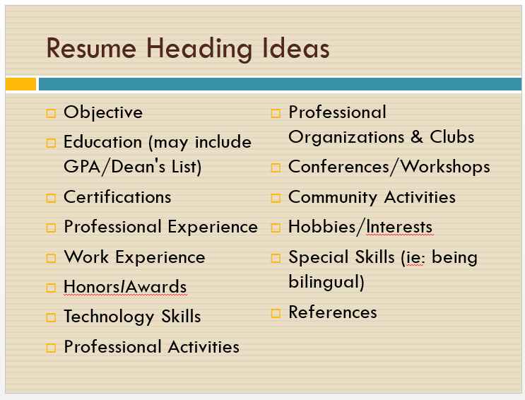

- You can use Microsoft Office or Google Docs resume templates. Some are better than others.

- Other places to find templates:
https://resumegenius.com/resume-templates
https://templates.office.com/en-us/Simple-resume-TM00002110

_____________________________________________________________________________________________

Information for Recommenders
- What do you feel are your strengths?
- What obstacles have you overcome?
- Name one achievement of which you are most proud.
- What are you looking forward to in college? How will the college or university meet your needs?
- What is your passion? What intrigues you?
- In what areas are you a leader inside or outside of the classroom, and how are you a leader?
- List six adjectives that best describe you.
- Is there any other information the recommender might need to know about you before writing your letter?

